# CS 255 System Design Document Template

Connor holohan 2/18/2025

## UML Diagrams

### UML Use Case Diagram

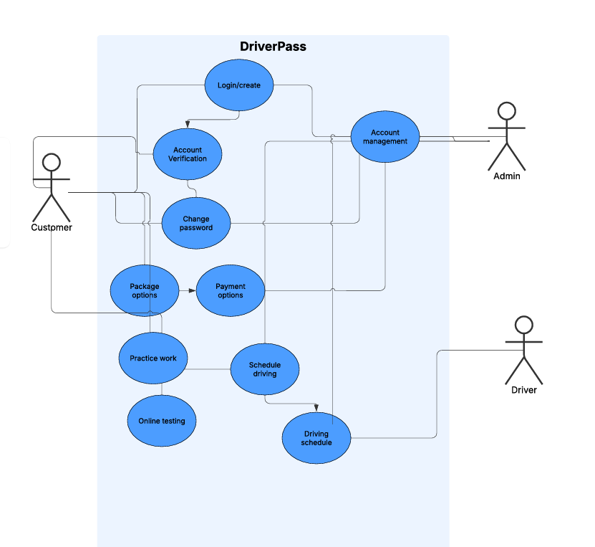

### UML Activity Diagrams

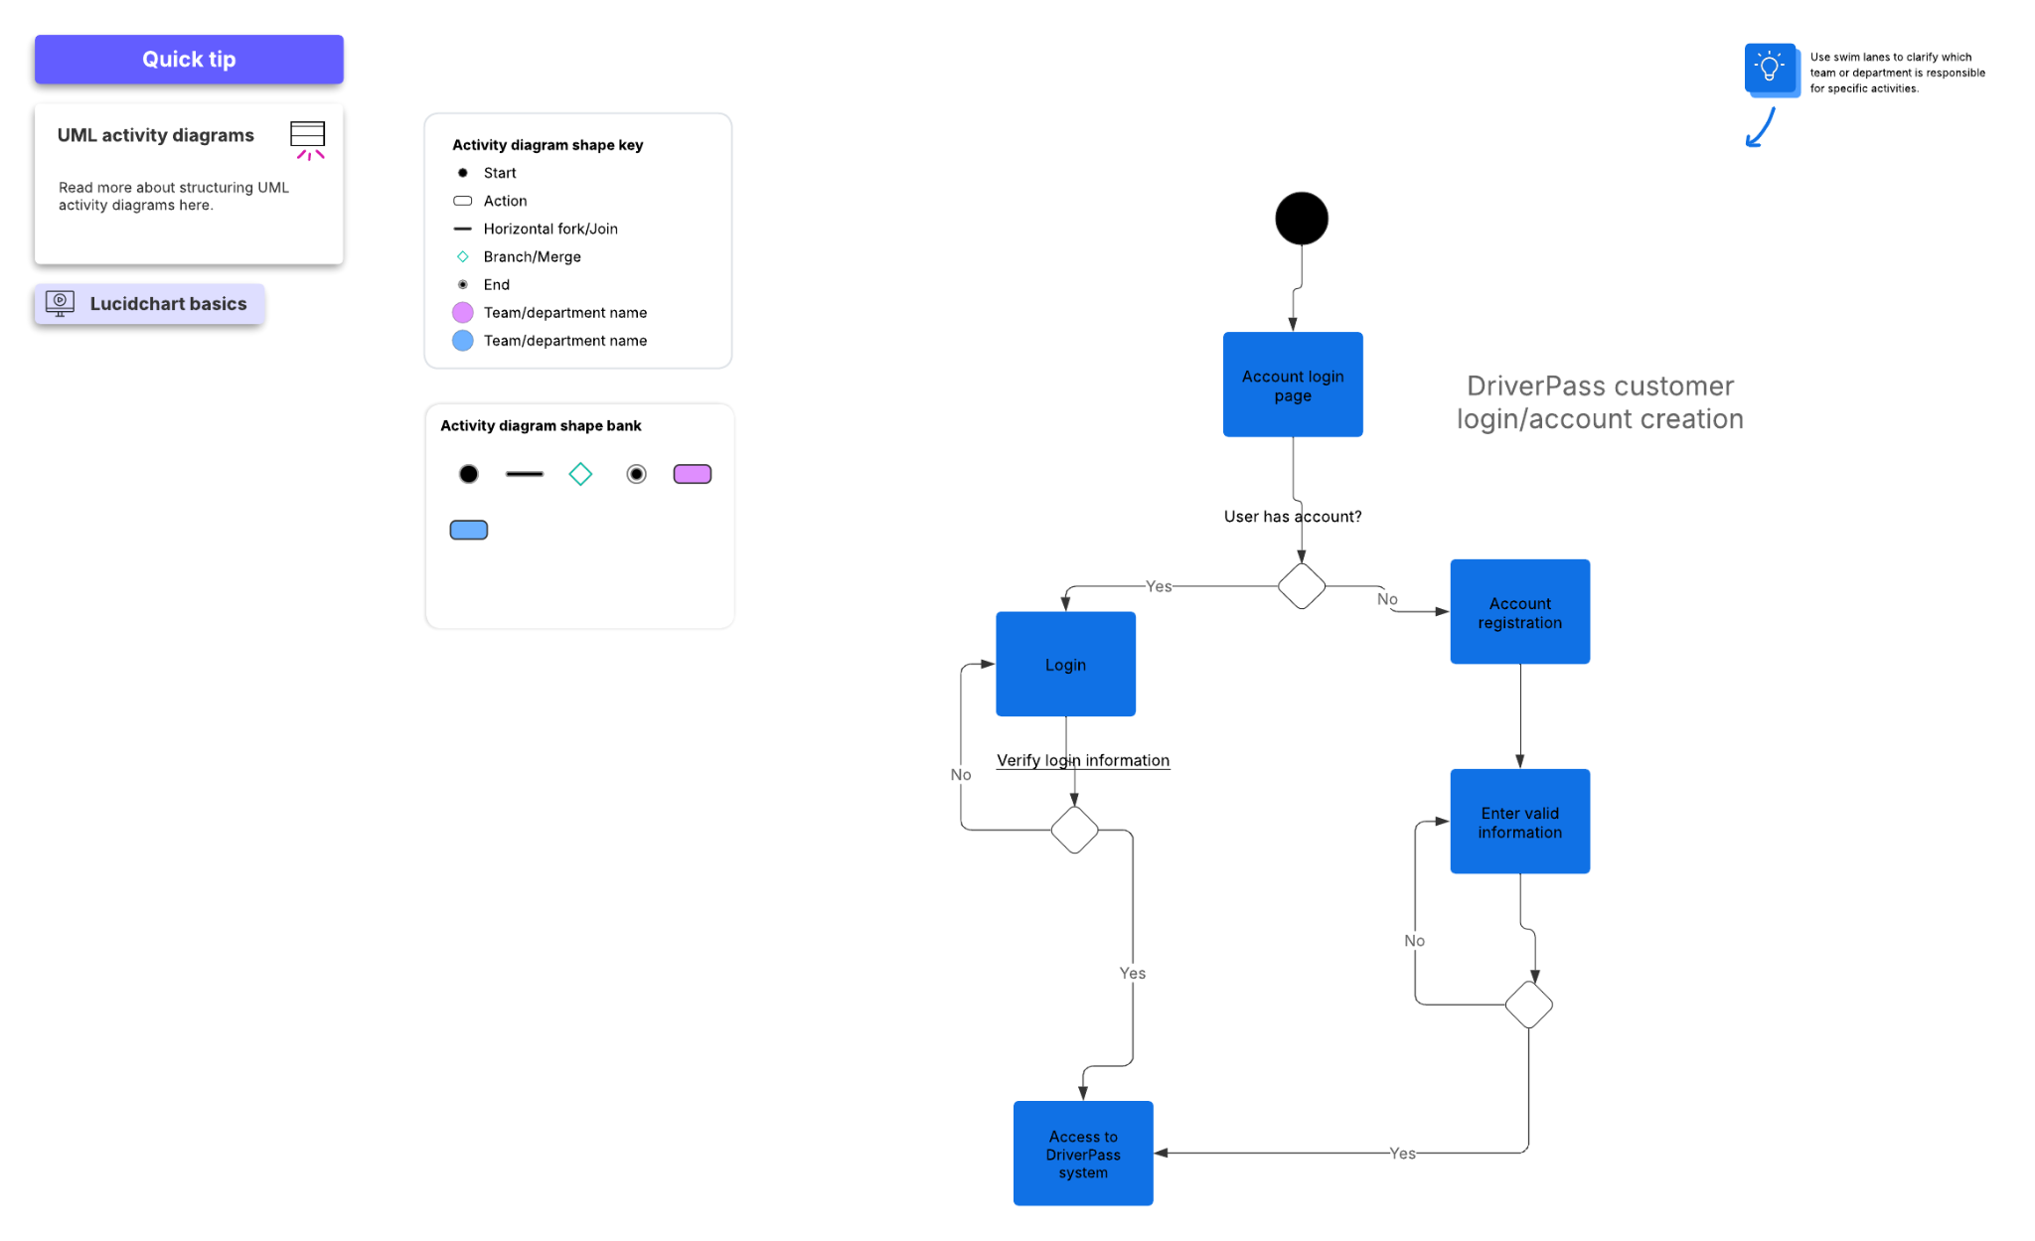

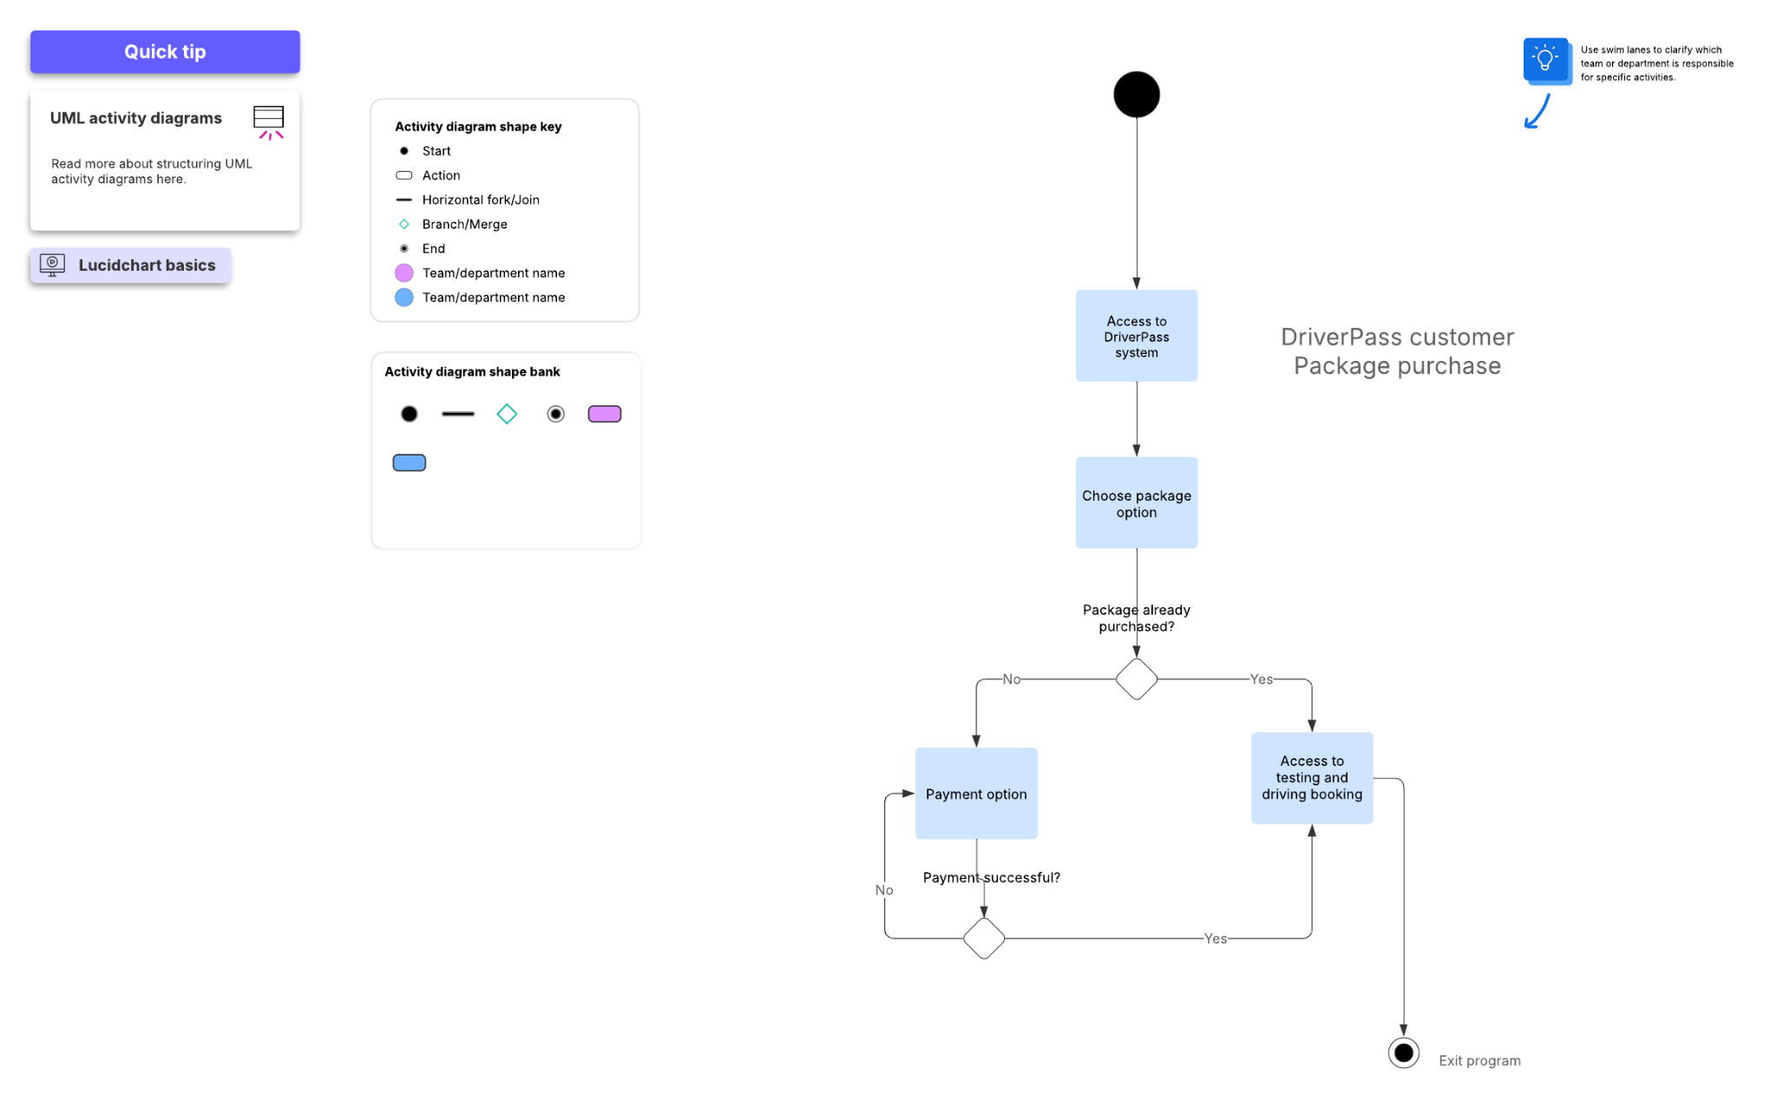

### UML Sequence Diagram

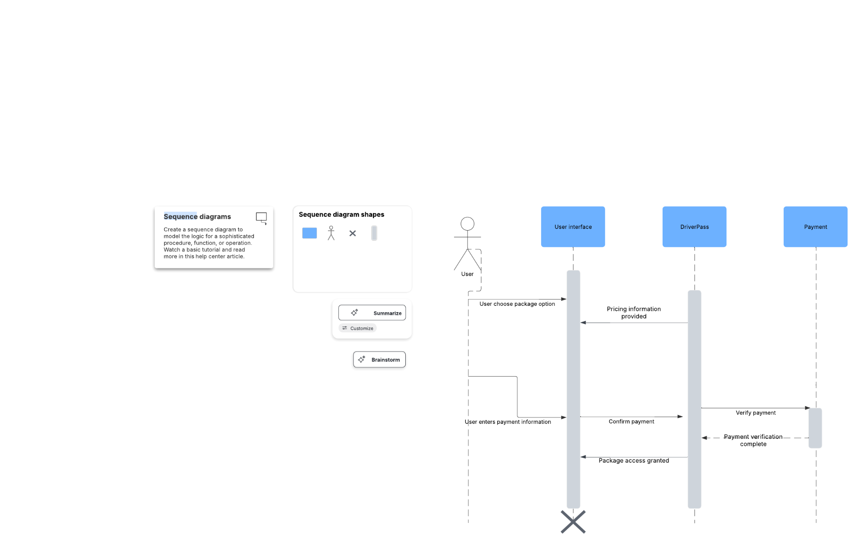

### UML Class Diagram

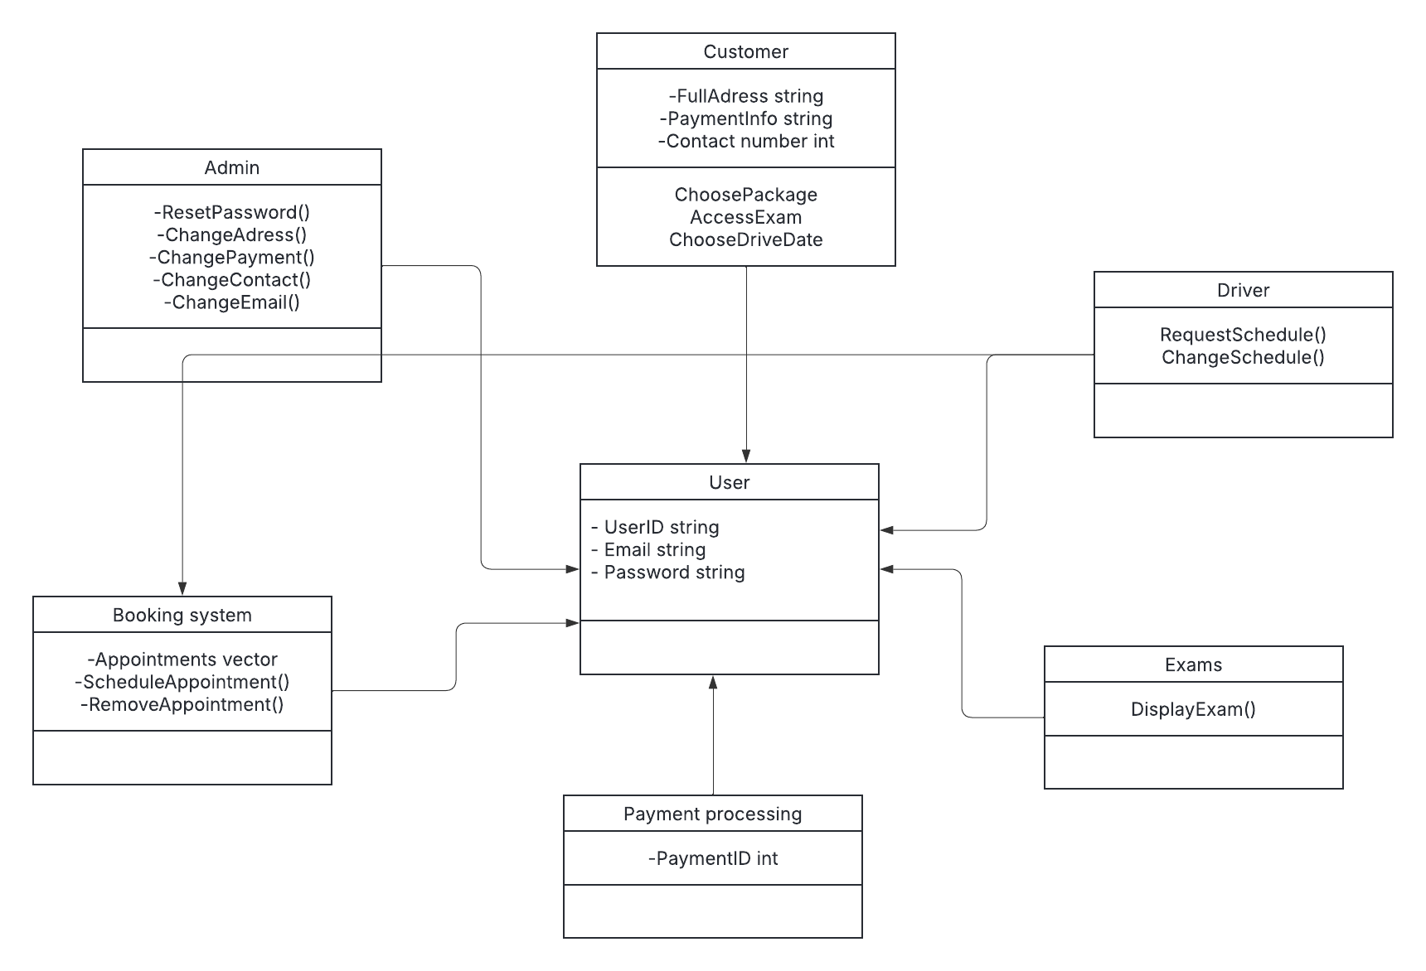

## Technical Requirements

*System Technical requirements*

* *System compatibility with modern operating systems and updates*
* *Payment Validation*
* *User access to testing material*
* *Dedicated Server*
* *Steady internet connection*
* *Desktop or mobile computer to access system*
* *Utilization of unique ID's and passwords*
* *Potentially 2 factor authentication*
* *Password Reset*
* *Modification of user account information*